**Retinal Structure-Function Assessment Framework**

**User Manual**

*Rijul S. Soans, Benjamin E. Smith, Susana T. L. Chung*

# Software Dependencies:

1. MATLAB r2022b (https://www.mathworks.com/products/matlab.html)
2. FIJI (https://imagej.net/software/fiji/)
3. OCT Explorer 3.8.0 (<https://iibi.uiowa.edu/oct-reference>) – required only if you want to try on your own dataset.

Note: The framework has been tested on the above software versions successfully. It may work on other versions but is not guaranteed.

# Installation:

1. Install MATLAB from the link provided above.
2. Install FIJI/ImageJ 1.54d from the link provided above.
3. Configure FIJI to work with MATLAB by adding it to the MATLAB path.

E.g., If FIJI was installed on the Desktop, then add the following to the MATLAB path: C:\Users\RS\Desktop\fiji-win64\Fiji.app\scripts

1. Copy the repo from GitHub to a suitable location on your PC.

# Project Folder Structure:

The repo contains 2 main folders: 1) Example data – which has the subject data, and 2) MOCT-RS-v1 – which has the program files. The overall structure tree is shown below. Please follow the same structure when testing out your own data.

└── **retina-struc-func-framework/**

├── **Example Data/**

│ ├── **Albinism/**

│ │ └── ALB_OD_Rectangular/

│ │ ├── MAIA/

│ │ │ ├── MAIA_exam_17_55.png (MAIA SLO Image)

│ │ │ ├── MAIA_exam_17_55_PSF.png

│ │ │ ├── maia-1275_17_55_fixation.txt

│ │ │ └── maia-1275_17_55_threshold.txt (MAIA Threshold File)

│ │ ├── OCT/

│ │ │ ├── bscans (OCT B-scans)/

│ │ │ │ └── 1.tif, 2.tif,...97.tif (or as acquired)

│ │ │ ├── 0E7376C0.xml

│ │ │ └── OCT.tif (OCT cSLO Image)

│ │ └── Result/

│ │ ├── bscans_Sequence

│ │ └── (Additional files appear here after analysis)

│ ├── **Amblyopia/**

│ │ └── AMB_OD_Rectangular/

│ │ ├── MAIA/

│ │ │ ├── MAIA_exam_43_155.png (MAIA SLO Image)

│ │ │ ├── MAIA_exam_43_155_PSF.png

│ │ │ ├── maia-1275_43_155_fixation.txt

│ │ │ └── maia-1275_43_155_threshold.txt (MAIA Threshold File)

│ │ ├── OCT/

│ │ │ ├── bscans (OCT B-scans)/

│ │ │ │ └── 1.tif, 2.tif,...97.tif (or as acquired)

│ │ │ ├── AA914B00.xml

│ │ │ └── OCT.tif (OCT cSLO Image)

│ │ └── Result/

│ │ ├── bscans_Sequence

│ │ └── (Additional files appear here after analysis)

│ └── **Healthy/**

│ └── H_OD_Rectangular/

│ ├── MAIA/

│ │ ├── MAIA_exam_10_69.png (MAIA SLO Image)

│ │ ├── MAIA_exam_10_69_PSF.png

│ │ ├── maia-1275_10_69_fixation.txt

│ │ └── maia-1275_10_69_threshold.txt (MAIA Threshold File)

│ ├── OCT/

│ │ ├── bscans (OCT B-scans)/

│ │ │ └── 1.tif, 2.tif,...97.tif (or as acquired)

│ │ ├── 15D4EB20.xml

│ │ └── OCT.tif (OCT cSLO Image)

│ └── Result/

│ ├── bscans_Sequence

│ └── (Additional files appear here after analysis)

└── **MOCT-RS-v1/**

├── UI_RSFAF.m (User Interface: Start with this file in MATLAB)

├── RunWrapperFunc.m (Wrapper Function)

├── Custom ImageJ plugins

└── Other helper functions

# Walkthrough:

1. Open the **UI_RSFAF.m** **file** located inside the **MOCT-RS-v1**  folder using MATLAB and press Run.

2. A GUI should appear showing different options as follows:

Fig. 1. GUI of the framework

3. Click on the “Start here: Instructions” button to open this document at any time.

4. On the left side of the panel, you have a couple of general checklists. Make sure that the OCT B-scans of a particular subject are appropriately placed as mentioned in Section III of this manual (Project Folder Structure). Check the box after confirming the same.

5. Similarly, make sure that you have the exported XML file from the OCT machine also in the appropriate place as per the project folder structure. Check the box after confirming the same.

6. On the right side, you have a registration panel which gives you two options: “Automatic Mode” or the “Manual Mode”. You can choose either. Here, we select the “Automated Mode” as an example.

7. Click on “Begin Analysis”

8. The GUI asks you to “select the OCT fundus image of a particular subject”. Navigate to Example Data 🡪 Any of the participant category i.e. “Healthy”, “Amblyopia” or “Albinism” 🡪 Subject ID 🡪 OCT🡪 OCT.tif

Eg: Desktop\retina-struc-func-framework\Example Data\Healthy\H_OD_Rectangular\OCT 🡪 and here single-click on “OCT.tif”

9. Next, the GUI asks you to select the MAIA image of the same subject.

Eg: Desktop\retina-struc-func-framework\Example Data\Healthy\H_OD_Rectangular\MAIA 🡪 and here single-click on “MAIA_exam_10_69.png”. There may be other png files with different suffixes such as MAIA_exam_10_69_P.png or _PSF or _SF or _S etc; don’t select these).

10. Next select the “Result” folder of the same subject.

Eg: Example Data 🡪 Healthy 🡪 H_OD_Rectangular 🡪and single click on the “Result” folder and then click on “Select Folder”.

11. Then the framework starts to place the B-scan lines accounting for eye movements. It uses the MATLAB Parallel Computing Toolbox to speed up the operation. It may take some time especially if you have started the PC after a gap. After this executes, you should see the following output:

Fig. 2. OCT B-scans according to eye movements. The scans are numbered and partially overlapping scans are highlighted in pink

12. Next the automatic co-registration begins. You will get a dialog box as follows:

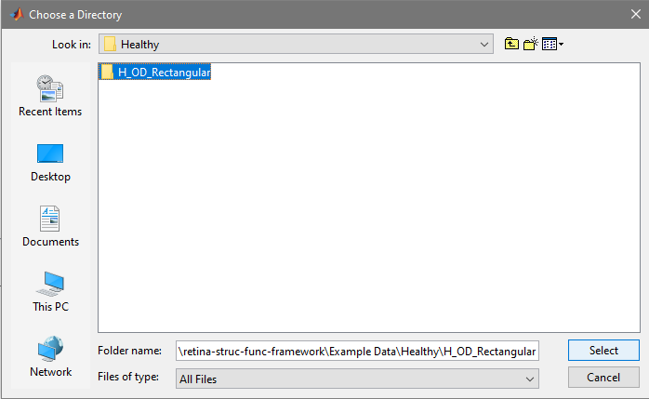

13. Single click on the Subject Folder. Eg: “H_OD_Rectangular” and click on “Select”.

14. The FIJI log file should open and you can see the processes running. At the end, you should get a GIF preview of the co-registration.

Fig. A GIF preview of the automated co-registration

15. Next, the framework asks if the registration preview looks okay. If you click, “Yes”, it proceeds with overlaying MAIA test points on the OCT SLO image. If you click “No”, the framework will try to perform remedial steps within the scope of the automatic registration method. It then asks again: “Now, does the registration shown in the preview look okay to you?”. If “Yes”, it proceeds with overlaying MAIA test points on the OCT SLO image. If “No”, it switches to the manual registration method.

Fig. 5. Automated registration preview dialog box

16. Next, it shows the MAIA sensitivity map overlayed on the OCT B-scans as shown below:

Fig. 6. MAIA map on OCT B-scans along with overlay

17. After this, it asks you “Is the co-registration acceptable to you”?. This is another check-point wherein if you select “No”, then it switches to the Manual Coregistration Method.

Fig. 7. If “Yes”, queries retinal thickness. If “No”, switches to manual coregistration method and tries again.

18. If you select “Yes”, then it queries the retinal thickness. The Results will be available in the “Results” folder.

Eg: retina-struc-func-framework\Example Data\Healthy\H_OD_Rectangular\Result\Retinal Thickness_Automatic.xlsx

**Manual Co-Registration Method:**

### 1. Follow Steps 1-5 in Section IV. Select “Manual Mode” in the panel.

2. Steps 7-11 are same as before.

3. Next the manual co-registration starts. Now the command prompt in MATLAB asks you to select at least between 6 and 10 corresponding points between the OCT and the MAIA image for manual registration. This is because the manual registration uses a projective transform which requires at least 4 corresponding points between the two images.

4. Once you enter a value between 6 and 10, the prompt also tells the user to select “good and interesting” points. These could be corners, edges, blobs etc. Select points from different regions of the image to ensure that the registration is not biased towards a particular area. Avoid selecting points on occlusions or reflections as they may introduce errors in registration. Moreover, try not to select 4 points which happen to be on the same line in a particular image (i.e. collinear) as they can introduce mathematical errors. See below (Fig. 8) for an example of “good and interesting” points.

Fig. 8. Illustration of selecting “good and interesting” points for the manual registration

1. So, select at least 6 such corresponding points. A big box pops up showing the MAIA image on the left and the OCT image on the right. For the first two corresponding points, you can use the single star button (labelled as Add points). Zoom in close to select the points accurately. Once at least two corresponding points are selected, then you can use the double star button (labelled as Add points and predict matches) to select the remaining corresponding points. If you select a point in one image, the program automatically predicts the location of the corresponding point in the other image. Fine-tune the location of the points using the mouse (and Pan button etc if required). At the end it should look something like the image below.

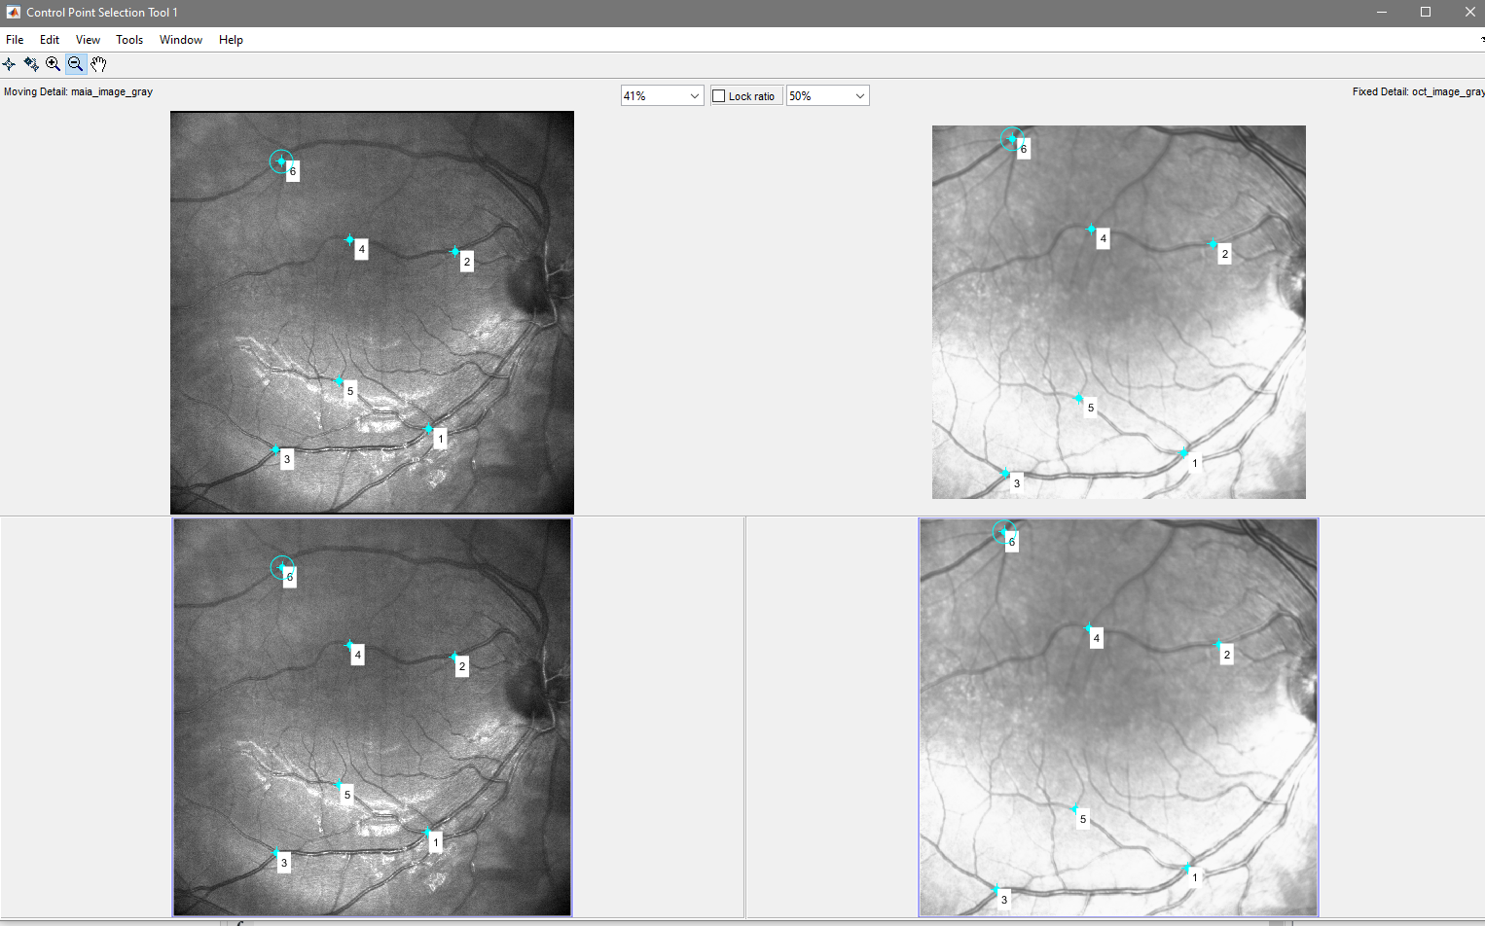

Fig. 9. Overall view after selecting atleast 6 corresponding points manually in the MAIA and the OCT image.

1. Once at least 6 points are selected, you can simply close the dialog box by clicking on the “X” on the top-right corner.
2. After some time, you should see 2 figures pop up. The first is the registered MAIA & OCT image (Fig. 10. below). The next is the MAIA sensitivity map overlayed on the OCT image (Fig. 11. below).

Fig. 10. Registered OCT and MAIA image overlayed.

Fig. 11. MAIA sensitivity map overlayed on the OCT image.

1. After this, it asks you “Is the co-registration acceptable to you”? Select “Yes” to continue. If you select “No” , then it will either tell you to try the manual alignment again with more number of points or tell you to try the automatic alignment.

Fig. 12. Dialog box asking if the co-registration output is appropriate.

1. If you select “Yes”, then it queries the retinal thickness. The Results will be available in the “Results” folder.

Eg: retina-struc-func-framework\Example Data\Healthy\H_OD_Rectangular\Result\Retinal Thickness_Manualxlsx

Fig. 13. Results in the excel sheet: Part 1

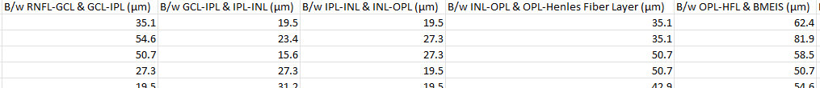

Fig. 14. Results in the excel sheet: Part 2

Fig. 15. Results in the excel sheet: Part 3